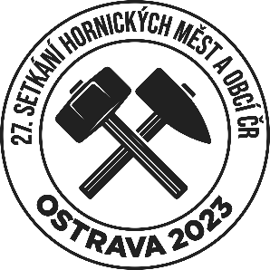

BINDING APPLICATION FORM

27th meeting of mining towns and villages
8-10 September 2023 in Ostrava

Name of city, organization, association:
Organization ID:
Contact person:
Phone:
E-mail:
Date of arrival:
Departure date:
Number of people:
Will you attend Friday's opening: | YES / NO*
Will you attend the Mayor's Welcome: | YES / NO*
Will you attend the Mining Parade: | YES / NO*
* delete as appropriate

Participativním fee (250 CZK/person)

Payment by bank transfer to account no.:
IBAN: CZ36 0800 0000 1916 4929 7309
BIC: GIBA CZ PX
Please fill in SHM 2023 + organization ID in the description of the transfer.

Please make the payment by 10 June 2023.

Deadline for applications:

Send the completed application form by 31 May 2023 to fajront@ostrava.cz or by post to:
Magistrát města Ostravy, Kancelář primátora, Prokešovo náměstí 1803/8, 702 00 Ostrava
Contact person: Dagmara Hýblová, T: +420 59944 2324

Excursions:

Associations that submit an application will receive an offer of excursions. The offer will be sent to the contact email above after 31 May 2023. Registration for all excursions will be on-line at fajront.ostrava.cz

